Họ và Tên: Nguyễn Phương Thiên Vũ
Lớp: 12_ĐH_CNTT5
MSSV: 1250080237

PHIẾU BÀI TẬP 2
a. Trigger UPDATE bảng XUAT – trg_CapNhatXuat
CREATE OR REPLACE TRIGGER trg_CapNhatXuat
FOR UPDATE ON Xuat
COMPOUND TRIGGER

BEFORE STATEMENT IS
BEGIN
pkg_state.g_row_count := 0;
END BEFORE STATEMENT;

BEFORE EACH ROW IS
v_soluong NUMBER;
v_chenhlech NUMBER;
BEGIN
pkg_state.g_row_count := pkg_state.g_row_count + 1;

IF pkg_state.g_row_count > 1 THEN
RAISE_APPLICATION_ERROR(-20001, 'Chi duoc cap nhat 1 dong');
END IF;

IF :NEW.SoLuongX != :OLD.SoLuongX THEN

v_chenhlech := :NEW.SoLuongX - :OLD.SoLuongX;

SELECT SoLuong INTO v_soluong
FROM SanPham
WHERE MaSP = :OLD.MaSP;

IF v_chenhlech > 0 THEN
IF v_soluong < v_chenhlech THEN
RAISE_APPLICATION_ERROR(-20002, 'Khong du hang de cap nhat');
END IF;
END IF;
UPDATE SanPham
SET SoLuong = SoLuong - v_chenhlech
WHERE MaSP = :OLD.MaSP;

END IF;

END BEFORE EACH ROW;

END trg_CapNhatXuat;
/
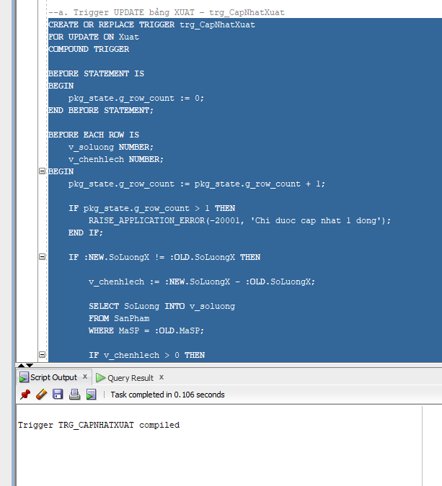
Test trigger:
UPDATE Xuat SET SoLuongX = 5;
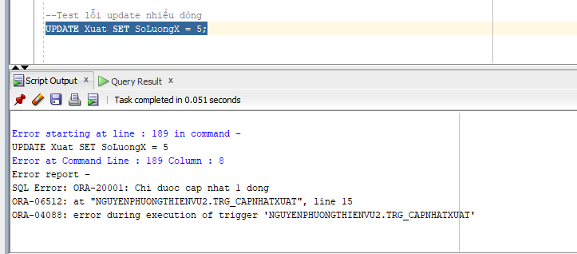
b. Trigger UPDATE bảng NHAP – trg_CapNhatNhap
CREATE OR REPLACE TRIGGER trg_CapNhatNhap
FOR UPDATE ON Nhap
COMPOUND TRIGGER

BEFORE STATEMENT IS
BEGIN
pkg_state.g_row_count := 0;
END BEFORE STATEMENT;

BEFORE EACH ROW IS
v_chenhlech NUMBER;
BEGIN
pkg_state.g_row_count := pkg_state.g_row_count + 1;

IF pkg_state.g_row_count > 1 THEN
RAISE_APPLICATION_ERROR(-20001, 'Chi duoc cap nhat 1 dong');
END IF;

IF :NEW.SoLuongN != :OLD.SoLuongN THEN

v_chenhlech := :NEW.SoLuongN - :OLD.SoLuongN;

UPDATE SanPham
SET SoLuong = SoLuong + v_chenhlech
WHERE MaSP = :OLD.MaSP;

END IF;

END BEFORE EACH ROW;

END trg_CapNhatNhap;
/
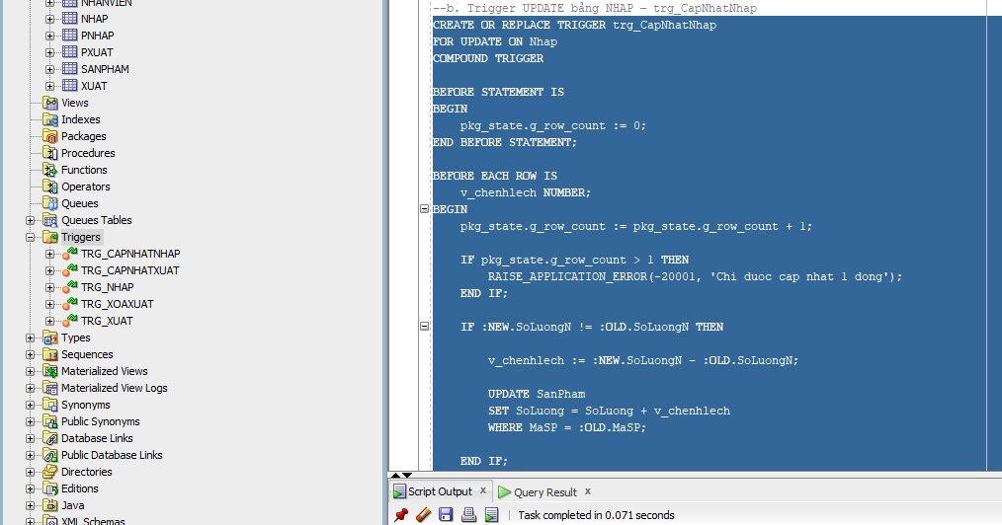
Test trigger
Trước khi upd
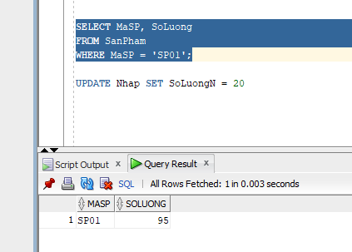
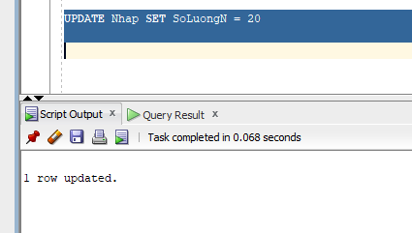
Sau khi upd
UPDATE Nhap SET SoLuongN = 20
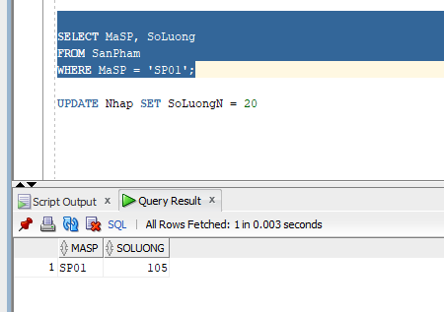
c. Trigger DELETE bảng NHAP – trg_XoaNhap
CREATE OR REPLACE TRIGGER trg_XoaNhap
AFTER DELETE ON Nhap
FOR EACH ROW
BEGIN
UPDATE SanPham
SET SoLuong = NVL(SoLuong,0) - :OLD.SoLuongN
WHERE MaSP = :OLD.MaSP;
END;
/
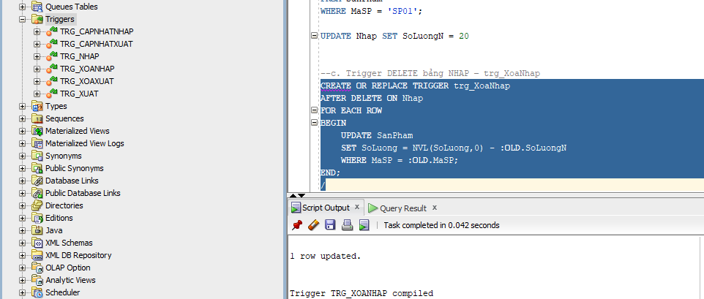
Test trigger
Trước khi delete
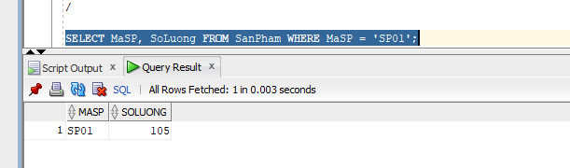
Sau khi delete
DELETE FROM Nhap
WHERE SoHDN = 'N01' AND MaSP = 'SP01';
